Maximising Payload Opportunities, with Loadscan’s Payload Management Solutions

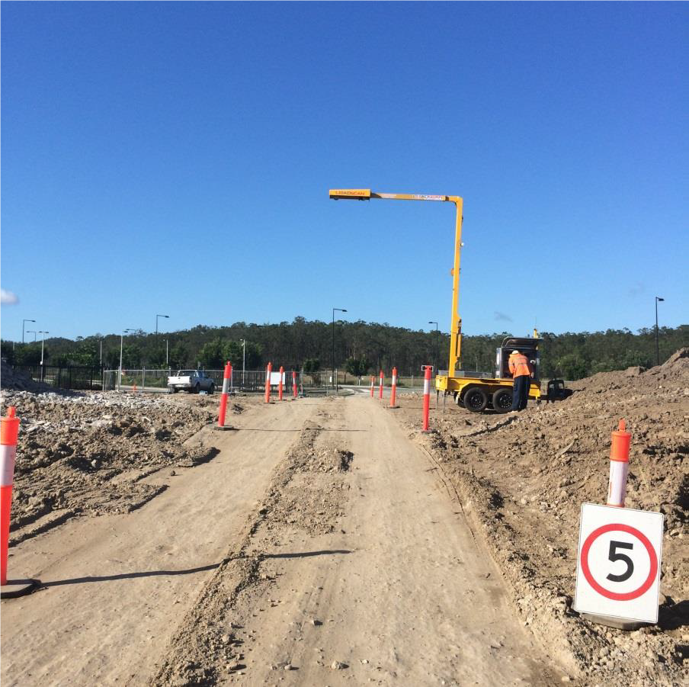
Project overview

Contractor Details: Customer

Project Name: Stage 1

Address: Brisbane

Description of Works: 60,000 CUM of Export Material

Equipment Rental: LoadScan Volume Scanner

Rental Commencement Date: 11th January 2016

Rental Completion Date: 5th February 2016

Traditional Methods

Traditional Methods of Determining Truck Measure (Buyer Side)

Common methods for checking volumetric truck measure at the point of unloading are:

• Level and measure (manual survey of levelled loads in truck bin using tape measure)

• Survey load on ground

• Survey stockpile (multiple loads)

• Unload truck/trucks into hole or container of known capacity.

• Measure truck capacity and count loads

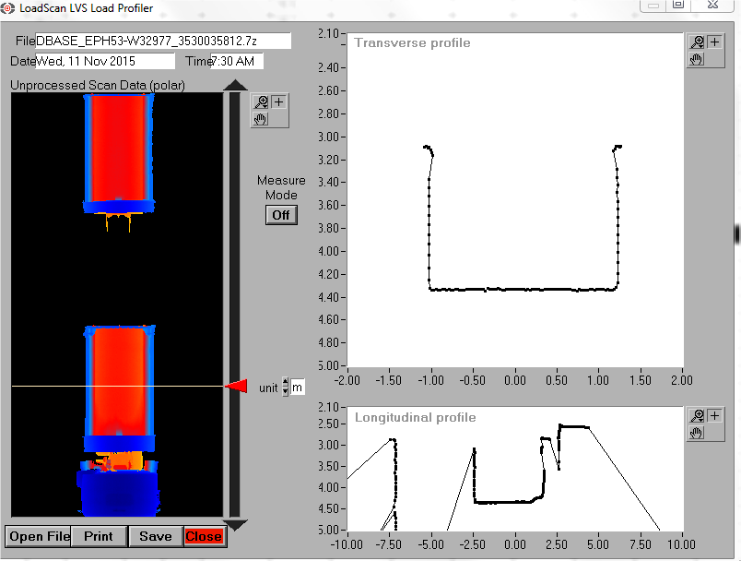
Loadscan System

Each truck was fitted with a RFID tag for automatic identification.

Each truck was scanned empty for a database reference scan to calculate payload in m³ for all truck and trailer configurations.

Each load was scanned on exit.
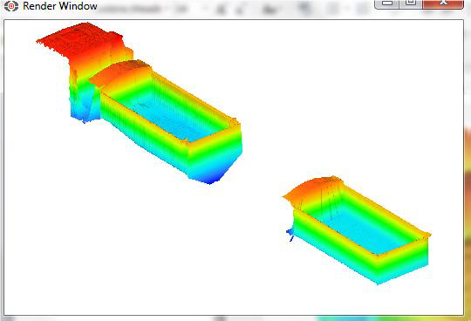
Total export material measured: 1667 loads 34,559 m³

This report illustrates by utilising the Loadscan system what commercial benefits exist and how the system can be used to monitor improvements in loading consistency, productivity and management of overloads for road legal requirements.

Truck Details

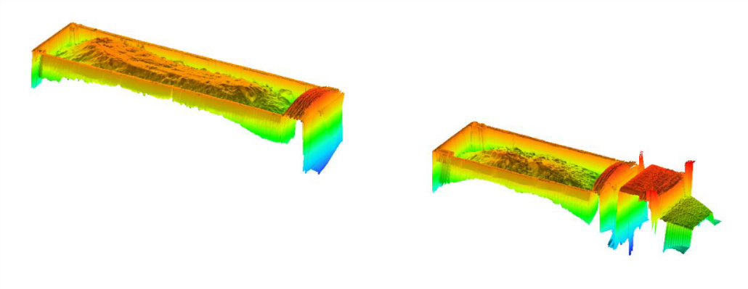
Truck types and details:

Carting company billing rate per m³ exported: $6.50 per m³

Agreed truck rates:

Truck and Quad-Trailers: 22 m³ per load @ $6.50 per m³ = $143 per load
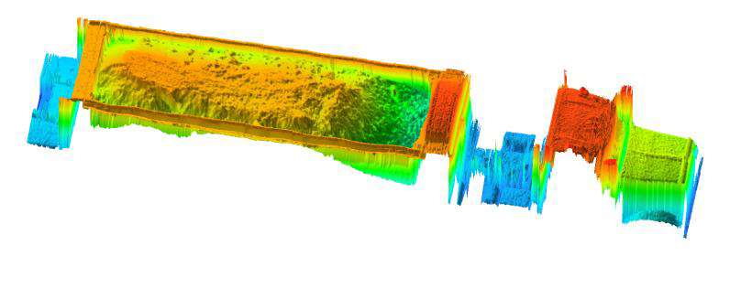
Truck and Tri-Trailers: 22 m³ per load @ $6.50 per m³ = $143 per load

Truck and Semi-Trailers: 20 m³per load @ 6.50 per m³ = $130 per load

Initial Results

Results below show the difference between what was measured to what was being paid for on the agreed per m³ truck rate.

The calculations below are based on one shift with 187 loads

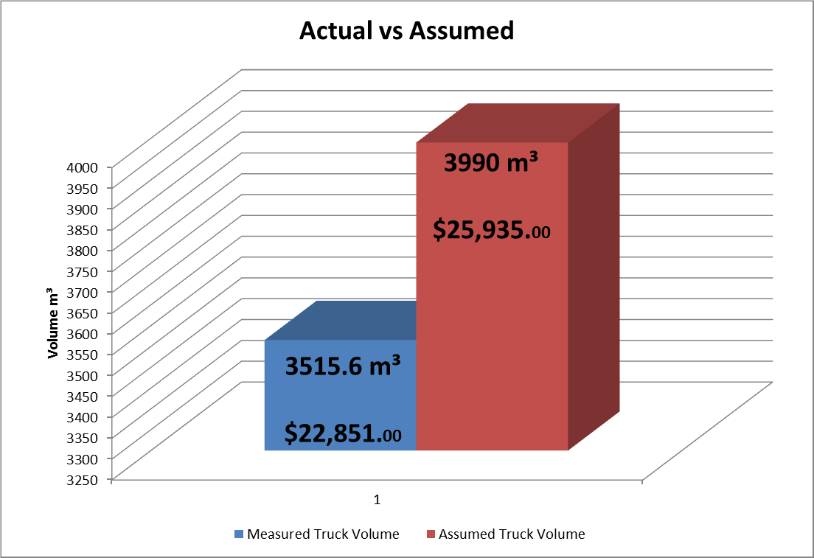
Total of 3515.6 m³ was measured in one shift @ $6.50 per m³
= $22,851.40 per day

Total of 3990.0 m³ agreed truck rate of @ $6.50 per m³ = $25,935.00 per day

Difference of 474.4 m³ = $3,084.00 per day

Assuming the same loading practice and truck loads per day,

$3084.00 x 6 days week = $18,504.00 loss per week

474.4 m³ x 6 day week = 2846.4 m³ of export equates to
approx. 130 truck loads at a 22m³ per load factor not being carted.

8 weeks would equate to $148,032.00 (22,771.2 m³)

Productivity

Results from the following week below show the increase in productivity and difference between what was measured to what was being paid for on the agreed per m³ truck rate.

The calculations below are based on one shift with 114 loads

Total of 2360.1 m³ was measured in one shift @ $6.50 per m³ = $15,340.65 per day

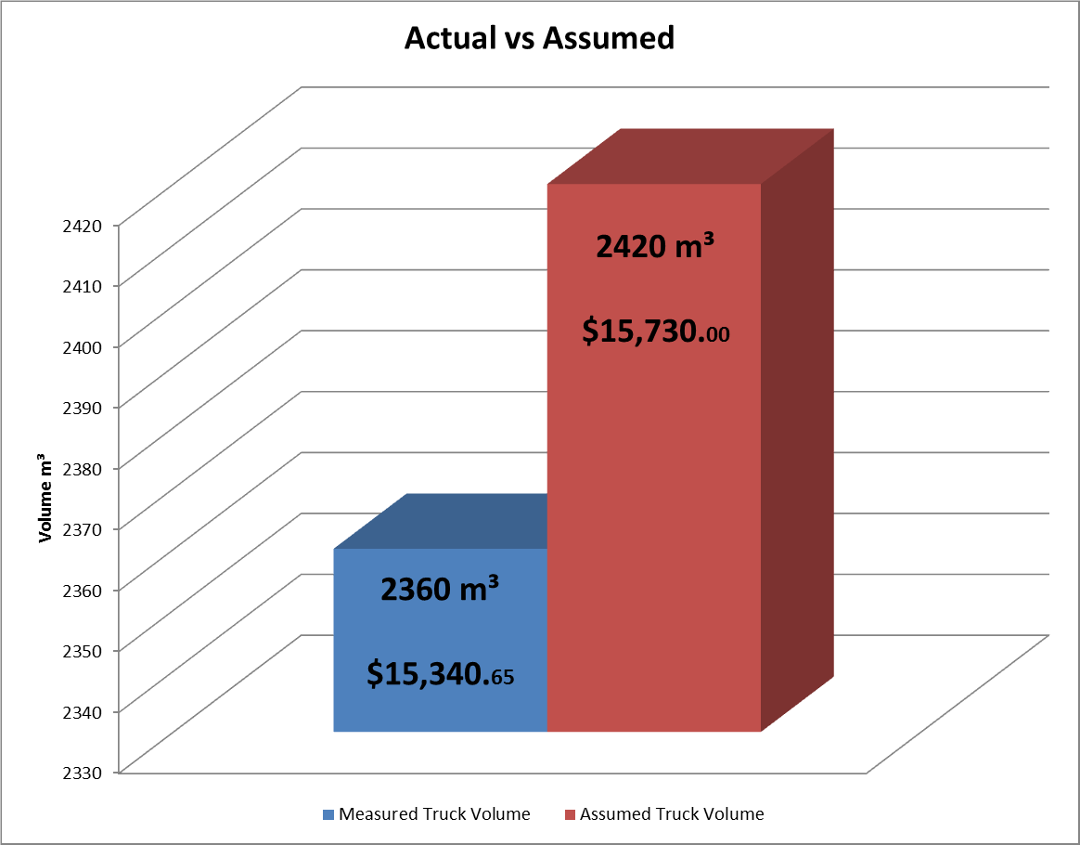
Total of 2420 m³ agreed truck rate of @ $6.50 per m³ = $15,730.00 per day

Difference of 60 m³ = $389.35 per day

$389.35 x 6 days week = $2,336.10 loss per week

60 m³ x 6 day week = 360 m³ of export equates to
approx. 16 truck loads at a 22m³ per load factor not being carted.

Big reduction in “lost cubic meters”

Density

Results from the Loadscan volume scanner and gross weights taken on a public weighbridge for selected trucks enabled the calculation of loose material density for specific material types. The table below shows the different density values for the three materials measured while onsite.
Material 1

Truck Type | Bin 1 Load (m3) | Bin 2 Load (m3) | Total (m3) | Tare (t) | Max GVW (t) | Measured weight (t) | Material | Density (t/m3) | Payload (t)
Truck & Trailer | 9.90 | 12.70 | 22.60 | 17.76 | 50.00 | 53.10 | 1 | 1.56 | 35.34

Material 2

Truck type | Total (m3) | Tare (t) | Max GVW (t) | Measured weight (t) | Material | Density (t/m3) | Payload (t)
Semi-Trailer | 17.00 | 20.00 | 42.50 | 49.34 | 2 | 1.73 | 29.34

Material 3

Truck type | Total (m3) | Tare (t) | Max GVW (t) | Measured weight (t) | Material | Density (t/m3) | Payload (t)
Semi-Trailer | 17.10 | 20.00 | 42.50 | 48.20 | 3 | 1.65 | 28.20

Overloading
With the density factor applied to the measured volume a payload value in tonnes can be calculated for each load.

Below are the calculations for the truck units that were weighed at the weighbridge. Initial results showed that trucks were loaded over their maximum load limits in all materials sampled.
Truck & Trailer

Bin 1 ID | Type | Bin 1 Load (m3) | Bin 2 ID | Bin 2 Load (m3) | Total (m3) | Tare (t) | Max GVW (t) | Measured weight (t) | Material | Density (t/m3) | Payload (t) | Max Payload (t) | Overload (t)
928SSW | Truck & Trailer | 9.9 | 252QWY | 12.7 | 22.6 | 17.76 | 50.0 | 53.1 | Test 1 | 1.56 | 35.34 | 32.24 | 3.1

Semi-Trailer

Bin 1 ID | Type | Bin 1 Load (m3) | Total (m3) | Tare (t) | Max GVW (t) | Measured weight (t) | Material | Density (t/m3) | Payload (t) | Max Payload (t) | Overload (t)
810QXR | Semi Trailer | 17 | 17 | 20.00 | 42.50 | 49.34 | 2.00 | 1.73 | 29.34 | 22.50 | 6.84

Bin 1 ID | Type | Bin 1 Load (m3) | Total (m3) | Tare (t) | Max GVW (t) | Measured weight (t) | Material | Density (t/m3) | Payload (t) | Max Payload (t) | Overload (t)
810QXR | Semi Trailer | 17.1 | 17.1 | 20.00 | 42.50 | 48.20 | 3 | 1.65 | 28.20 | 22.50 | 5.70

Target Volume

Target Volume to manage truck mass load limits for road compliance
The tonnes calculation enables management of maximum mass load limits for each particular truck configuration. Loading to target volume using an accurate material density value will reduce the risk of overloading in relation to the trucks maximum allowable load limits and be in compliance with DTMR.

Below are some examples of calculated target volumes based on a known material density value and the trucks maximum mass limits.

Type | Tare (t) | Max GVW (t) | Material Density (t/m³) | Max payload (t) | Target Volume (m³)
Truck & Trailer | 17.76 | 50.00 | 1.56 | 32.24 | 20.7

Type | Tare (t) | Max GVW (t) | Material Density (t/m³) | Max Payload (t) | Target Volume (m³)
Semi Trailer | 20.00 | 42.50 | 1.56 | 22.50 | 14.42

Summary

• Loadscan’s Load Volume Scanning system has proven to be a more accurate measurement of material movements when compared to traditional methods
• Big opportunities to reduce export carting costs and increase your profit
• Billing carting company for m³ measured not assumed.
• Big improvements in loading consistency and productivity
• Semi trailers are the least productive when compared to truck and trailers
• Use volume data and weighbridge results to calculate loose material density
• Apply density values to material types to calculate tonnes
• Load to target volume to manage truck specific mass load limits
• Compliance with mass load limits will reduce the risk of fines for overloading
• Chain of responsibility
https://www.loadscan.com/

